THEORY QUESTIONS
1.
(a)

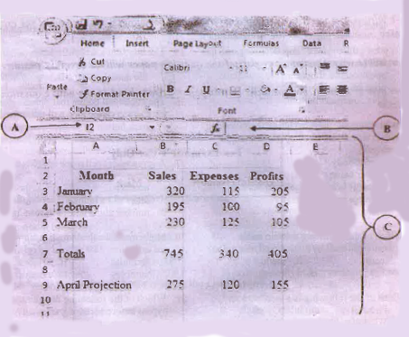
Use the above diagram to answer questions (i) to (iv).
(i)

Name the application program used for the above figure.
(ii)

Write the formula/function used to calculate the profit for cell D7.
(iii)

Write the formula/function used to calculate the total expenses for cell C7.
(iv)

Name the parts labelled A, B and C.
(b)

Complete the table below.
Windows button | Name of windows button | Function of windows button

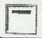


(c)

In a word processing application, what is the command button print preview used for?

2.
(a)

State the data types for the following characters as used in spreadsheet application.
(i)

13.65
(ii)

24.04'
(iii)

=SUM(A5:G5)
(iv)

=A4+C8-G25
(v)

+233244971100
(b)

What does formatting a disk refer to?

3.
List
(a)

two toggle keys on a standard computer keyboard.
(b)

three features of a web browser.
(c)

two components of the central processing unit.
(d)

two operating system software.
(e)

three health hazards associated with prolonged use of computers and ICT tools.

4.
(a)

Give two examples of a typing software.
(b)

Certain books are published both in hard copies and soft copies (e-books).
Give two reasons for using
(i)

hard copies formats;
(ii)

soft copies formats.
(c)

Arrange the storage devices, compact disc, hard disk and pen drive in descending order of
(i)

access speed;
(ii)

storage capacity.

5.
State the purpose of the following commands on an email application such as yahoo or gamil:
(a)

My Account;
(b)

Compose;
(c)

Attach;
(d)

Sign Up.

